## Assembly Design and DMU Kinematics

* ***Step 1:***

Go to Mechanical Design and select Assembly Design and start inserting existing components by making Product 2 as caller.

Following is the series of components to be called in order:

Crank Case

4 pistons

4 pins

Crank Shaft (with offset)

Connecting rod 1 (with offset 11)

Connecting rod 2 (with offset 22)

* ***Step 2:***

Fix crank case and call pistons. Insert them all in product 2 as shown:

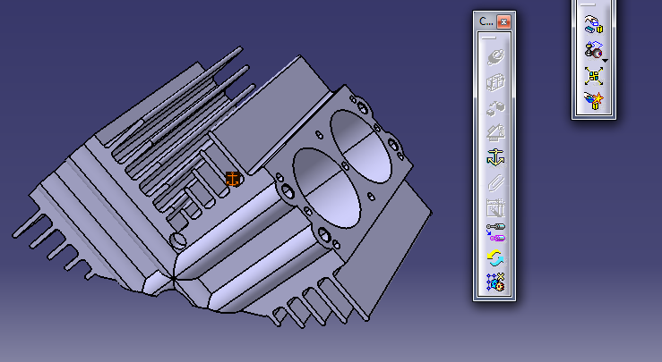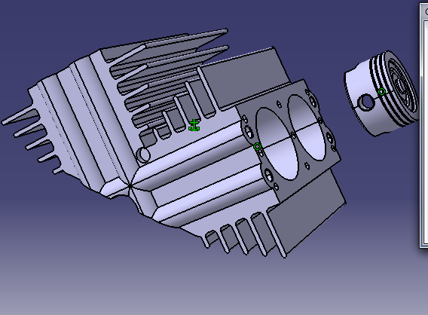

Repeat it for all 4 pistons.

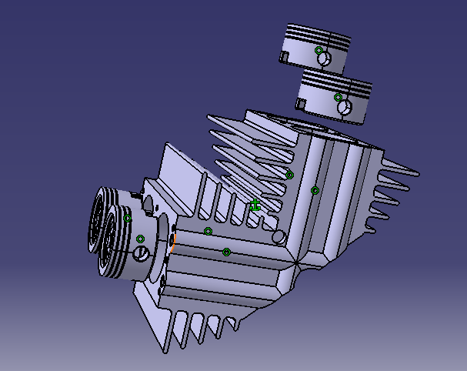

* ***Step 3:***

Now call pins for all 4 pistons and insert after applying constraints as shown below.

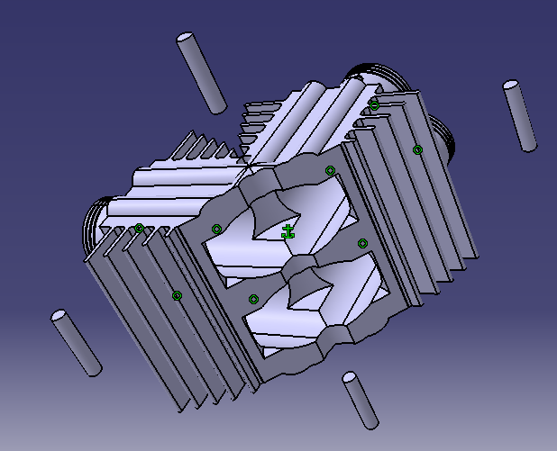

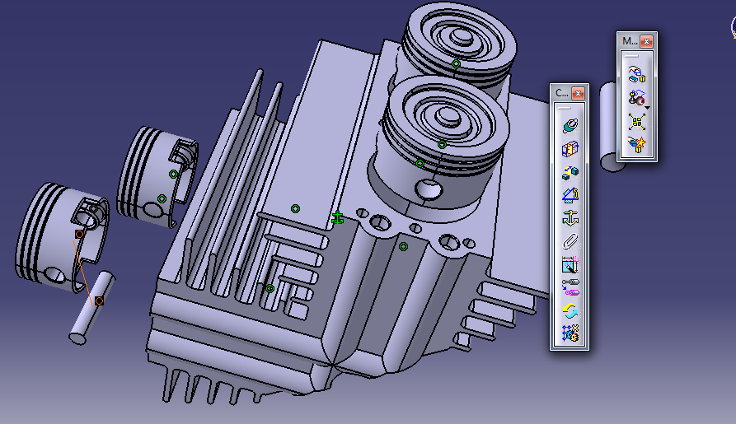

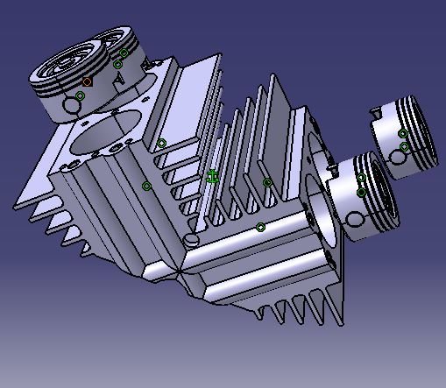

* ***Step 4:***

Hide Crank case and insert Crank shaft and connecting rod 1 as shown and apply following offset and constraints.

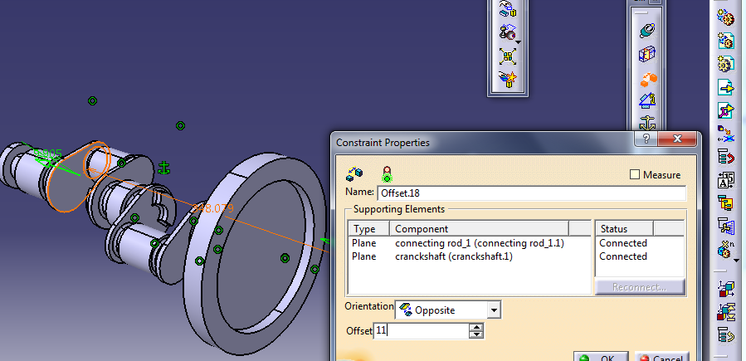

* ***Step 5:***

Now call connecting rod 2 and give it following offset and required constraints.

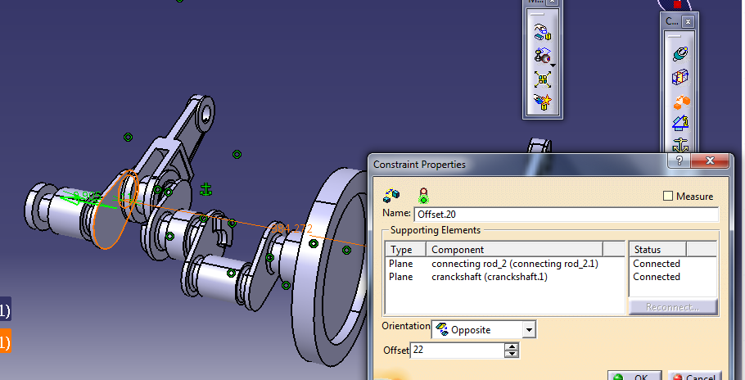

* ***Step 6:***

After updating it will look like

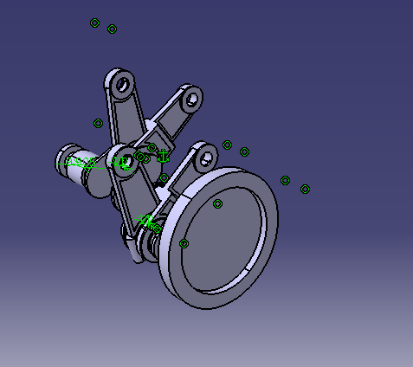

* ***Step 7:***

After the final fixing the engine will look like

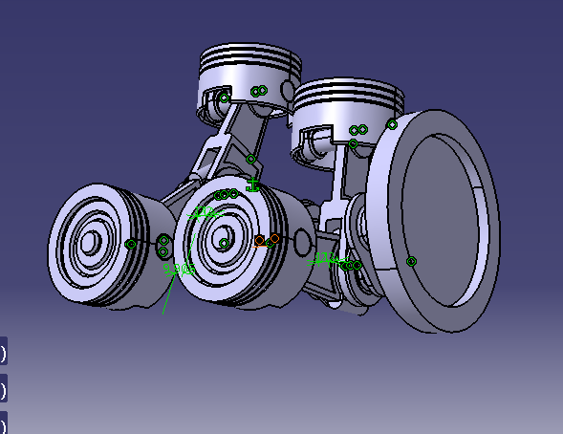

* ***Step 8:***

Now go to DMU Kinematics and select Cylinder 1 and after applying following shown commands show the animation.

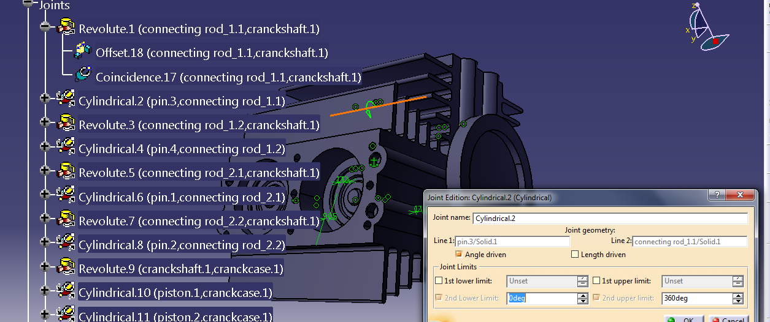

* ***Step 9:***

Click on  Simulation.

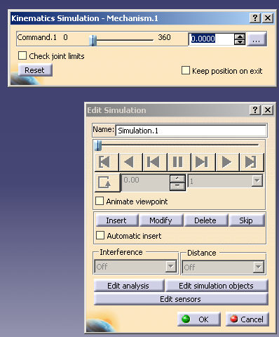

Click on Insert

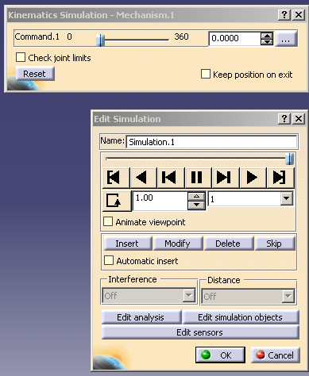

Adjust as follows after clicking insert

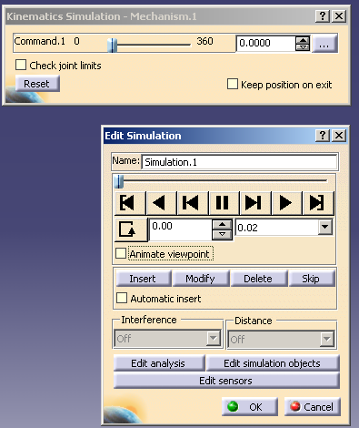

Now move the upper roller to 360deg

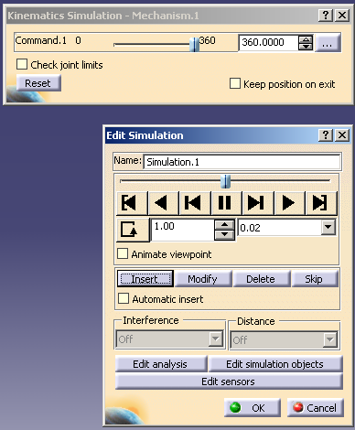

Now play mechanism.